1.

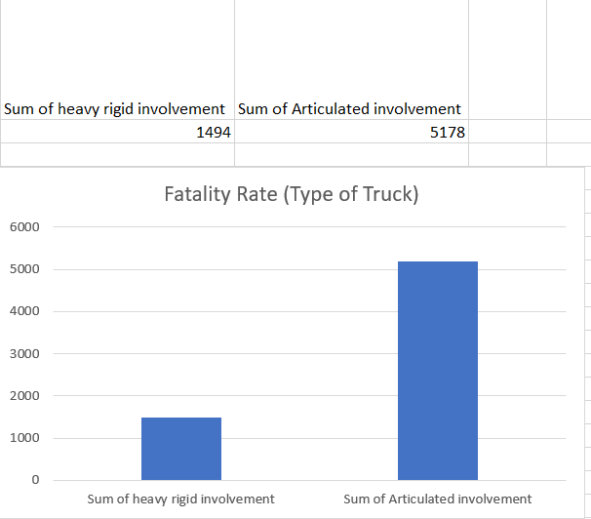

**Which data attributes (columns) do you need to answer this question?**

|  |  |
| --- | --- |
| **Heavy Rigid Truck Involvement** | **Articulated Truck Involvement** |

**Do you need to transform any of the data?**

Yes, the unknown data is removed.

**Does the data type change when you transform the data? If so how**

It does not change, as I removed the unknown data from the dataset.

2.

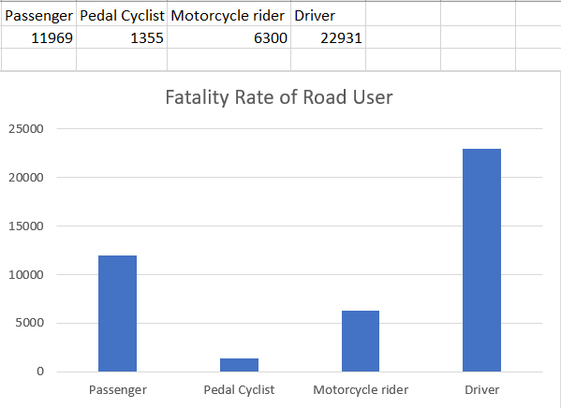

**Which data attributes (columns) do you need to answer this question?**

Road UserRoad User

**Road U  
Do you need to transform any of the data?**

Yes, the unknown data is removed.

**Does the data type change when you transform the data? If so how**

It does not change, as I removed the unknown data from the dataset.

3.

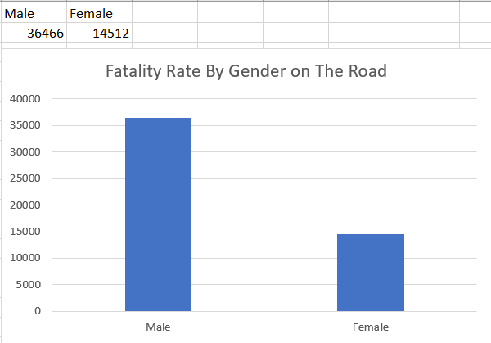

**Which data attributes (columns) do you need to answer this question?**

Gender

**Road U  
Do you need to transform any of the data?**

Yes, the unknown data is removed.

**Does the data type change when you transform the data? If so how**

It does not change, as I removed the unknown data from the dataset.